

**Avanza Capital Holdings Continues to Strengthen Community Bonds with Generous Contribution to the Jewish Community Center of Staten Island**

Staten Island, NY – January 24, 2025 – Avanza Capital Holdings, a leading alternative funding company specializing in innovative funding solutions and diversified portfolio of capital allocations, proudly announces its support for the Jewish Community Center of Staten Island, Inc. through a meaningful charitable contribution. This donation will specifically benefit the Sunrise Day Camp, a transformative program that provides children with cancer and their siblings a safe space to enjoy the joys of summer in a supportive and uplifting environment.

“I just donated to this incredible program, and it means a great deal to me personally,” said Francesco Scarso, CEO of Avanza Capital Holdings. “Sunrise Day Camp holds a special place in my heart because my daughter volunteered there two summers ago. She saw firsthand the heartbreak these children endure and was deeply moved by their strength and resilience. She came home in tears many days, touched by the impact this camp had on these kids and their families.”

Sunrise Day Camp, run by the Jewish Community Center of Staten Island, offers a free, full-summer day camp experience tailored to children with cancer and their siblings. It provides a sense of normalcy and joy during a time that is anything but normal for these families. Avanza Capital Holdings’ donation will help ensure this life-changing program can continue to serve its mission.

“We are honored to support the Jewish Community Center of Staten Island and the Sunrise Day Camp,” Scarso added. “This program doesn’t just provide smiles and summer memories; it offers hope and healing. We encourage others to join us in supporting this cause and making a difference in the lives of these brave children.”

The team at the Jewish Community Center of Staten Island expressed their gratitude, stating: “It’s the generosity of companies like Avanza Capital Holdings that allows us to create programs that truly change lives. This donation will help us continue to bring joy and support to families when they need it most.”

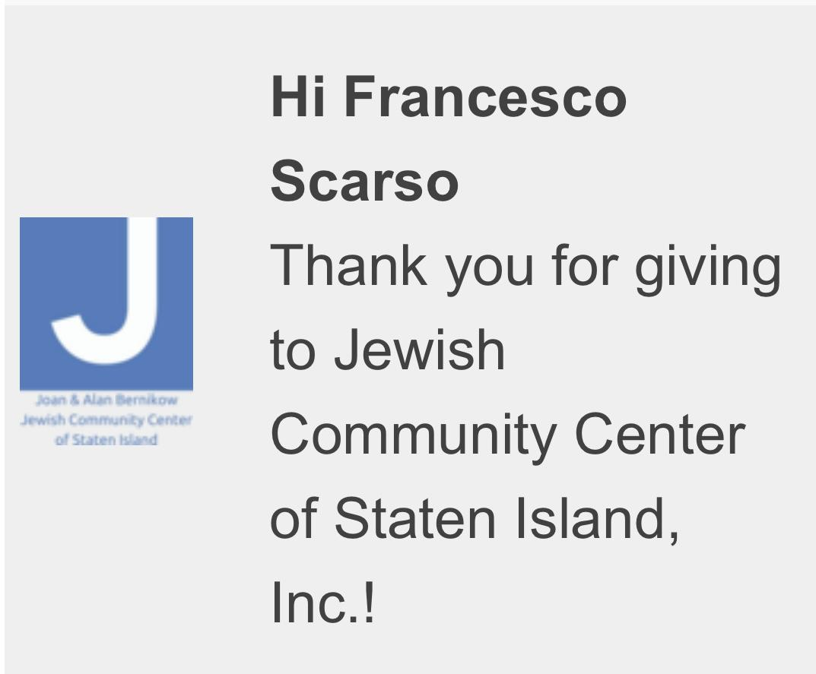

Avanza Capital Holdings remains dedicated to making a meaningful impact in the communities it serves. By supporting programs like the Sunrise Day Camp, the company reaffirms its commitment to creating a brighter future for individuals and families in need.

For more information about Avanza Capital Holdings and its community initiatives, please visit [insert website:

https://avanza.nyc/

Media Contact:

Frank Scarso CEO

[frank@avanza.nyc](mailto:frank@avanza.nyc)

212-457-1336

Anthony DeBenedictis Partner

[anthony@avanza.nyc](mailto:anthony@avanza.nyc)

914-536-7565

